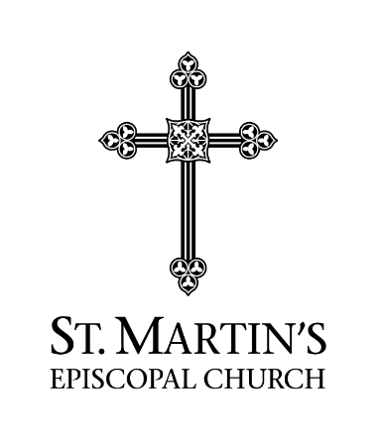
2023 St. Martin’s Grant
Follow Up Report

Organization: _________________________
Follow Up Report for Operational Year: ___ /___ to ___ /___
Execution of Grant Programs:
In 2023, did Agency serve clients and provide services to the designated target population as proposed in your 2023 Grant Request Form. Yes [ ] No [ ]
If “no”, attach an explanation for the change(s) in the execution of the Grant programs.
2023 # of Clients Planned to Serve | 2023 # of Clients Actually Served
Expenditure of Grant:
Were Grant funds spent in the manner described in the 2023 Grant Request Form: Yes [ ] No [ ]
If “No”, attach an explanation for change in requested Grant expenditure
Was SMEC notified of change? Yes [ ] No [ ]
Attestation:
“In accord with the best information available to the Organization for the 2023 Operational Year, the information provided to SMEC is true and accurate”
_________________________________________________
Officer of Organization
Operational Results for the 2023 Scope of Grant and Operational Year:
- Total number of individual clients receiving at least one service _______
- Total number of services provided to all clients: ______________________
- Total number of individual clients who “graduated” having successfully achieved the Organization criteria-of-completion ________
- Total number of individual clients who departed/withdrew from the Organization without having achieved the criteria-of-completion________
Targeted Sustained Outcomes for the 2023 Scope of Grant and Most Recent 12 Months Available:
- Present measured, quantitative outcomes from Agency Program(s) intended to have lasting improvement in client well-being
- State qualitative impact from Agency Program(s) intended to achieve a sustained improvement in client well-being
Attach requested information about the results achieved by Organization if available.

