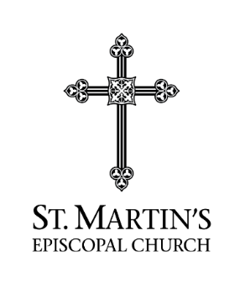
2024 St. Martin’s Grant
Follow Up Report
Operational Year ___/___ to ____/____

Agency Responsible for Grant Performance and Outcomes:___________________________
Execution of Grant Programs:
In the Operational Year, did Agency serve clients and provide services to the designated target population as proposed in your 2024 Grant Request Form. Yes [ ] No [ ]
If “no”, attach an explanation for the change(s) in the execution of the Grant programs.
2024 As Planned | 2024 Actual
Clients Served: | Clients Served:
Total Services: | Total Services:
Graduated Clients: | Graduated Clients:
Expenditure of Grant:
Were Grant funds spent in the manner described in the 2024 Grant Request Form: Yes [ ] No [
If “No”, attach an explanation for change in requested Grant expenditure.
Was SMEC notified of change? Yes [ ] No [ ]
Attestation:
“In accord with the best information available to the Agency for the 2024 Operational Year, the information provided to SMEC is true and accurate”
_________________________________________________
Officer of Organization
Targeted Sustained Outcomes for the immediate past operational year:
- State measured, quantitative outcomes from Agency Operations(s) intended to have lasting improvement in client well-being
- State qualitative impact from Agency Operations intended to achieve a sustained improvement in client well-being
- Attach requested information about the results achieved by the Agency if available.
Operational Results for the 2024 Scope of Grant and Operational Year:
- Did you reach your target population by geographic area: Yes [ ] No [ ]
- Did you reach your target population by income status or other demographic factor: Yes [ ] No [ ]
- Percent of clients reaching targeted “strategic” outcomes: __________________
- Explain achievement of planned improvements in measuring performance and strategic outcomes in the past year (attach explanation)
- List three top areas for improving measurement and outcome performance for 2025 based on 2024 operational experience. (attach list)

